**END OF 3RD TERM EXAMINATION**

**ACADEMIC YEAR 2020-2021**

**SECTOR: ICT**

**TRADE: SOFTWARE DEVELOPMENT**

**RTQF LEVEL: LEVEL V**

**MODULE CODE AND TITLE: SFDWA501-WEB APPLICATION DEVELOPMENT**

**DURATION: 3 HOURS**

**INSTRUCTIONS TO CANDIDATES:**

This paper contains three sections: Section A, B and C.

**SECTION A: ALL QUESTIONS ARE COMPULSORY /55MARKS**

**SECTION B: THIS SECTION IS COMPOSED BY THREE COMPULSORY QUESTIONS/30MARKS**

**SECTION C: CHOOSE ONE QUESTION OF YOUR CHOICE/15MARKS**

### SECTION A: ALL QUESTIONS ARE COMPULSORY 55marks

1. XAMPP is a cross-platform package useful to create web based application . What the acronym XAMPP stands for? What are the package components of XAMPP? State the importance of each component while you are developing your web based application? **/5marks**
2. Describe PHP program structure **/2marks**
3. Explain the use of the following functions?

a. count() b. var_dump() c.round() d.ceil() e. MySQLi_query( ) **/2.5marks**

1. Differentiate the three PHP variable scopes. /3marks
2. Differentiate PHP constants FROM PHP variables /2marks
3. With an example explain the use of PHP global Keyword . /2marks
4. When do we need to :

a. Use comparison operators ? Give 2 examples of comparisons operators **/2marks**

b. Logical operators ? Give 2 examples of logical operator **/2marks**

### Pushing operation is defined as Adding new elements to the end of an array, which function do we use to do this? /2marks

1. In order to echo or print out sorted arrays one of the 2 functions are used to return a string with the elements of an array. Name them. **/2marks**
2. Differentiate PHP built in function and user defined PHP function? Give the syntax for each. **/2marks**
3. Differentiate the following errors : i. Syntax errors: ii. Logical errors: iii. Run time errors: **/3marks**

### Write a php statement that open and write a text in Microsoft Excel.(file name is newfile) /3marks

1. A domain name **localhost** is mapped to which IP address? **1mark**
2. A. Explain the following statement:” PHP codes are embedded inside HTML codes ”,Give an example of a script where PHP codes are embedded inside HTML codes. **/5marks**
3. a. Define session then outline the benefits of using session in a web application(any 3) **/3marks**
4. Write a php code that will produce the following output: NB(the page background is green)

*Welcome to php script!*

*A very popular programming language!!*  **/2marks**

1. Write a php code that will output "Have a good day!" if the current time is less than 20, and "Have a good night!" otherwise **/ 2marks**
2. 3. When we are integrating database with a website we pass through 3 layers. Explain these layers? **3marks**

19. What are four (4) constraints commonly used in MYSQL? **/2marks**

20. What is the difference between server-side scripting and client-side scripting? **/2marks**

21.Answer by True or False

The following elements are used to establish interaction between application and data storage.

1. www  **0.5mark**
2. Password  **0.5mark**
3. Localhost **0.5mark**
4. URL  **0.5mark**
5. Database name **0.5mark**

**Section B: This section is composed by three compulsory questions**

**30marks**

22. a) Define PHP framework?

b) List any 3 PHP framework you know.

23. Assume that you are called for interview before being a task of creating database and connect to website of a company MGT ltd, then the interviewer asks you the following questions:

1. What do you know about DBMS? **(3marks)**
2. In your own words, talk about two (2) advantages of DBMS? **(3marks)**
3. What do you mean by a web application? **(2marks)**
4. Which query did you use to add foreign key? **(2marks)**

24. Refers to the following code:

<FORM NAME="myform" ACTION="" METHOD="GET">

Enter something in the box: <BR>

<INPUT TYPE="text" NAME="inputbox" VALUE=""><P>

<INPUT TYPE="button" NAME=" Save" Value="Click"onClick="testResults(this.form)">

</FORM>

Give the role of:

1. ACTION attribute **2marks**
2. METHOD attribute **2marks**
3. Text value **2marks**
4. Button value **2marks**
5. What will happen when we use **POST** instead of **GET** as value of method?**2marks**

**Section C: Choose one in two questions of your choice 15marks**

25.By referring to the following exhibit

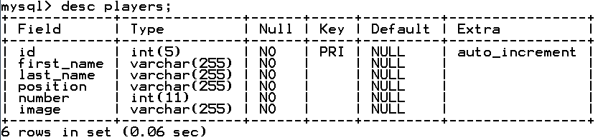

1. What does the pictures show?**2marks**
2. Write the query for creating the table players**4marks**
3. What do you mean by auto increment? **3marks**
4. List all data types from table players**3marks**
5. Remove field last_name from players table**3marks**

26.Consider the form below, write HTML, CSS and server side scripting chosen code to insert and retrieve the records in a single web page as follow.

database’s name: **berwashop** and table’s name:**product /15marks**

